**SPRINT 6**

**REVIEW**



**Author: Imagineers Team**

**Date: 26/05/2017**

**Revision history**

|  |  |  |  |
| --- | --- | --- | --- |
| **Version** | **Date** | **Author** | **Notes** |
| **1.0** | 26/05/2017 | Thạch Nguyễn |  |
|  |  |  |  |
|  |  |  |  |

**TABLE OF CONTENT**

I. SPRINT 6- BACKLOG 4

II. SPRINT 6- BURNDOWN 4

III. SPRINT 6- TASK REPORT 5

IV. SPRINT 6- CHECKLIST 11

V. SPRINT 6- SUMMARY 13

# SPRINT 6- BACKLOG

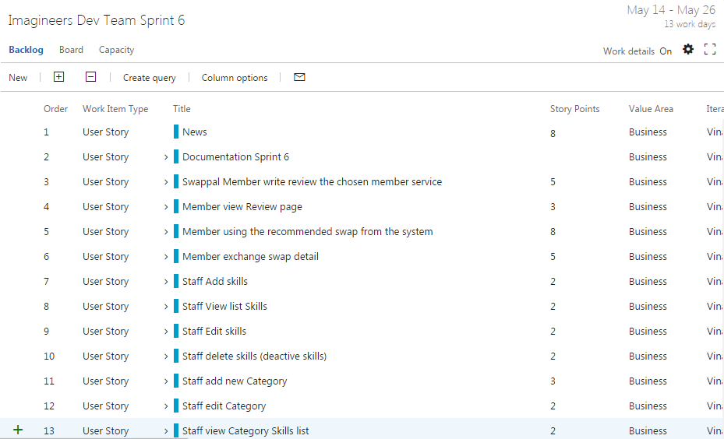

# SPRINT 6- BURNDOWN

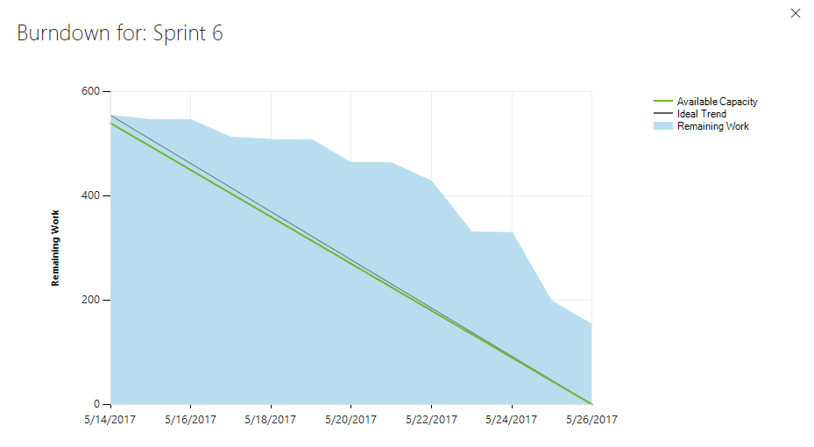

* Total estimated effort hours: 572 hours
* The actual effort hours: 393 hours
* The undone tasks hours: 179 hours

# SPRINT 6- TASK REPORT

|  |  |  |  |  |  |
| --- | --- | --- | --- | --- | --- |
| User story | Task | Assigned | Estimation (hrs) | Actual | Status |
| (hrs) |
| Documentation | Collect Sprint Artifact | Thach Nguyen | 6 | 8 | done |
|  | Report sprint and prepare presentation | Thach Nguyen | 16 | 18 | done |
| Swappal write review | Code client side – write review | Quang Nguyen | 12 | 14 | done |
|  | Code server side – write review | Chanh Tran | 12 | 16 | done |
|  | Run functional test | Viet Dang | 2 | 2 | done |
|  | Design database scheman | Thach Nguyen | 8 | 6 | done |
|  | Review code | Chanh Tran | 2 | 2 | done |
|  | Build deploy – write review | Quang Nguyen | 2 | 1 | done |
|  | Write test report – write review | Viet Dang | 2 | 1 | done |
| Member view review page | Code client side | Quang Nguyen | 18 | 18 | done |
|  | Code server – side | Chanh Tran | 16 | 12 | done |
|  | Build Deploy | Thach Nguyen | 4 | 3 | done |
|  | Review code | Chanh Tran | 2 | 1 | done |
| Member use recommended swap | Code HTML/CSS | Viet Dang | 8 | 2 | done |
|  | Code client side | Quang Nguyen | 12 | 4 | done |
|  | Code server side | Chanh Tran | 12 | 2 | done |
|  | Build and deploy | Thach Nguyen | 4 | 2 | done |
|  | Write test report | Viet Dang | 2 | 1 | done |
|  | Run functional test | Viet Dang | 2 | 2 | done |
| Member exchange swap detail | Code client side | Quang Nguyen | 24 | 18 | done |
|  | Write functional test | Viet Dang | 4 | 3 | done |
|  | Run functional test | Viet Dang | 2 | 1 | done |
|  | Build deploy exchange swap | Thach Nguyen | 4 | 2 | done |
| Staff add skill | Code HTML/CSS | Quang Nguyen | 4 | 6 | done |
|  | Code client side | Quang Nguyen | 8 | 8 | done |
|  | Code server side | Chanh Tran | 8 | 6 | done |
|  | Write unit test – client side | Tai Nguyen | 4 | 2 | done |
|  | Run unit test – client side | Tai Nguyen | 4 | 2 | done |
|  | Write unit test – server side | Tai Nguyen | 4 | 3 | done |
|  | Run unit test – server side | Tai Nguyen | 4 | 2 | done |
|  | Write functional test case | Viet Dang | 4 | 2 | done |
|  | Run functional test | Viet Dang | 2 | 1 | done |
|  | Review code | Chanh Tran | 2 | 1 | done |
|  | Write test report | Viet Dang | 2 | 1 | done |
|  | Write use case – add skill | Phuong Nguyen | 2 | 1 | done |
|  | Build and deploy | Thach Nguyen | 4 | 2 | done |
| Staff view skill | Code HTML/CSS | Quang Nguyen | 8 | 4 | done |
|  | Code client side | Quang Nguyen | 16 | 5 | done |
|  | Code server side | Chanh Tran | 16 | 7 | done |
|  | Design UI | Phuong Nguyen | 2 | 1 | done |
|  | Write unit test – client side | Tai Nguyen | 4 | 2 | done |
|  | Run unit test – client side | Tai Nguyen | 4 | 2 | done |
|  | Write unit test – server side | Tai Nguyen | 4 | 4 | done |
|  | Run unit test – server side | Tai Nguyen | 4 | 3 | done |
|  | Write functional test case | Viet Dang | 4 | 2 | done |
|  | Run functional test | Viet Dang | 2 | 1 | done |
|  | Review code | Chanh Tran | 2 | 1 | done |
|  | Write test report | Viet Dang | 2 | 1 | done |
|  | Write use case – view skill | Phuong Nguyen | 2 | 1 | done |
|  | Build and deploy | Thach Nguyen | 4 | 3 | done |
| Staff edit skill | Code HTML/CSS | Quang Nguyen | 5 | 6 | done |
|  | Code client side | Quang Nguyen | 8 | 6 | done |
|  | Code server side | Chanh Tran | 8 | 7 | done |
|  | Design UI | Phuong Nguyen | 2 | 1 | done |
|  | Write unit test – client side | Tai Nguyen | 4 | 2 | done |
|  | Run unit test – client side | Tai Nguyen | 4 | 1 | done |
|  | Write unit test – server side | Tai Nguyen | 4 | 2 | done |
|  | Run unit test – server side | Tai Nguyen | 4 | 1 | done |
|  | Write functional test case | Viet Dang | 4 | 1 | done |
|  | Run functional test | Viet Dang | 2 | 1 | done |
|  | Write test report | Viet Dang | 2 | 1 | done |
|  | Write use case – edit skill | Phuong Nguyen | 2 | 1 | done |
|  | Build and deploy | Thach Nguyen | 4 | 2 | done |
| Staff delete skill | Code HTML/CSS | Quang Nguyen | 5 | 2 | undone |
|  | Code client side | Quang Nguyen | 8 | 2 | undone |
|  | Code server side | Chanh Tran | 8 | 3 | undone |
|  | Design UI | Phuong Nguyen | 2 | 1 | done |
|  | Write unit test – client side | Tai Nguyen | 4 | 3 | done |
|  | Run unit test – client side | Tai Nguyen | 4 | 1 | done |
|  | Write unit test – server side | Tai Nguyen | 4 | 1 | done |
|  | Run unit test – server side | Tai Nguyen | 4 |  | done |
|  | Write functional test case | Viet Dang | 4 | 1 | undone |
|  | Run functional test | Viet Dang | 2 |  | undone |
|  | Review code | Chanh Tran | 2 |  | undone |
|  | Write test report | Viet Dang | 2 |  | undone |
|  | Write use case – delete skill | Phuong Nguyen | 2 | 1 | undone |
|  | Build and deploy | Thach Nguyen | 4 | 2 | undone |
| Staff add category | Code HTML/CSS | Quang Nguyen | 8 | 6 | done |
|  | Code client side | Quang Nguyen | 8 | 10 | done |
|  | Code server side | Chanh Tran | 8 | 10 | done |
|  | Design UI | Phuong Nguyen | 2 | 1 | done |
|  | Write unit test – client side | Tai Nguyen | 4 | 2 | done |
|  | Run unit test – client side | Tai Nguyen | 4 | 1 | done |
|  | Write unit test – server side | Tai Nguyen | 4 | 2 | done |
|  | Run unit test – server side | Tai Nguyen | 4 | 1 | done |
|  | Write functional test case | Viet Dang | 4 | 1 | done |
|  | Run functional test | Viet Dang | 2 | 1 | done |
|  | Review code | Chanh Tran | 2 | 2 | done |
|  | Write test report | Viet Dang | 2 | 1 | done |
|  | Write use case – add category | Phuong Nguyen | 2 | 1 | done |
|  | Build and deploy | Thach Nguyen | 4 | 3 | done |
| Staff edit category | Code HTML/CSS | Quang Nguyen | 5 | 4 | done |
|  | Code client side | Quang Nguyen | 8 | 6 | done |
|  | Code server side | Chanh Tran | 8 | 7 | done |
|  | Design UI | Phuong Nguyen | 2 | 1 | done |
|  | Write unit test – client side | Tai Nguyen | 4 | 3 | done |
|  | Run unit test – client side | Tai Nguyen | 4 | 2 | done |
|  | Write unit test – server side | Tai Nguyen | 4 | 3 | done |
|  | Run unit test – server side | Tai Nguyen | 4 | 2 | done |
|  | Write functional test case | Viet Dang | 4 | 1 | done |
|  | Run functional test | Viet Dang | 2 | 1 | done |
|  | Review code | Chanh Tran | 2 | 2 | done |
|  | Write test report | Viet Dang | 2 | 1 | done |
|  | Write use case – edit category | Phuong Nguyen | 2 | 1 | done |
|  | Build and deploy | Thach Nguyen | 4 | 4 | done |
| Staff view category | Code HTML/CSS | Quang Nguyen | 8 | 6 | done |
|  | Code client side | Quang Nguyen | 16 | 10 | done |
|  | Code server side | Chanh Tran | 8 | 10 | done |
|  | Design UI | Phuong Nguyen | 2 | 2 | done |
|  | Write unit test – client side | Tai Nguyen | 4 | 3 | done |
|  | Run unit test – client side | Tai Nguyen | 4 | 2 | done |
|  | Write unit test – server side | Tai Nguyen | 4 | 4 | done |
|  | Run unit test – server side | Tai Nguyen | 4 | 3 | done |
|  | Write functional test case | Viet Dang | 4 | 1 | done |
|  | Run functional test | Viet Dang | 2 | 1 | done |
|  | Review code | Chanh Tran | 2 | 2 | done |
|  | Write test report | Viet Dang | 2 | 1 | done |
|  | Write use case – view category | Phuong Nguyen | 1 | 1 | done |
|  | Build and deploy | Thach Nguyen | 4 | 5 | done |

# SPRINT 6- CHECKLIST

|  |  |  |  |
| --- | --- | --- | --- |
| Category | Detail | Artifacts | Status |
| User Story Clarity | User stories selected for the sprint are complete with respect to product theme, understood by the team, and have been validated by the detailed acceptance criteria. | Product backlog/ User story | Done |
| Tasks Identified | Tasks for selected user stories have been identified and estimated by the team. - |  | Done  Each story or task has ID  Task ID conduct on team service tool |
| Product owner approval | Each finished user story has been passed through UAT (User Acceptance Testing) and signed off as meeting requirements | References : Acceptance test | Imagineers-AcceptanceTest |
| Updating Product Backlog | All features not done during the sprint are added back to the product backlog. All incidents/defects not handled during the sprint are added to the product backlog. | Imagineers-BacklogRefinement | Done |
| Environment ready | Development environment is ready with all third-party tools configured.  Staging environment is ready.  Continuous integration framework is in place  Test data for the selected features has been created | Task management : Team service  Coding: Visual code  Document: Microsoft Office  Configuration tool: GitHub |  |
| Design complete | Design analysis is complete as per the user story or theme.  Prototype have been created and approved by the respective stakeholders.  Use cases are developed | Imagineers-Usecase  Imagineers-Prototype | Complete 100% story designs and use cases |
| Unit test cases written | Unit test cases have been written for the features to be developed |  | Developed :   * All the stories in this sprint |
| Documentation Ready | Documentation to support the sprint demo is ready |  |  |
| Code Complete | Source code changes are done for all the features in the “to do” list.” Source code has been commented appropriately. |  | Developed except:   * Delete skills * Using recommended swap |
| Unit testing is done | Unit test cases have been executed and are working successfully |  | Developed :   * All the stories in this sprint |
| Code Refactoring | Source code has been refactored to make it comprehensive, maintainable and, amenable to change. |  | Done in GitHub |
| Code checkin | Source code is checked in the code library with appropriate comments added. |  | Done in GitHub |
| Code merging and tagging | Finalized source code has been merged with the main branch and tagged appropriately (merging and tagging guidelines are to be used) |  | Done in GitHub |
| Project metrics are ready | Burndown chart has been updated regularly and is up to date. |  | Burndown chart is developed |
| Functional testing done | Test team has reviewed and conducted necessary manual test cases to ensure that tests are passing. All incidents/defects are reported.  100% executed test cases and 80% test cases pass.  There are no major defect occurred  Accept 20% minor defects in layout or the defect doesn’t affect system | Imagineers-TestCase  Imagineers-TestReport | Done : all pass except:   * Delete skills * Using recommended swap |
| Acceptance testing done | Each finished user story has been passed through UAT (User Acceptance Testing) and signed off as meeting requirements (see also Product Owner Approval). | Imagineers-AcceptanceTest | Acceptance test done except:   * Delete skills * Using recommended swap |
| Closure | All finished user stories/tasks are marked complete/resolved. Remaining hours for task set to zero before closing the task. |  | There are a lot of undone task  Reference on III.Task Report |

# SPRINT 6- SUMMARY

* There are still some undone tasks leads to failure in done the stories ( Reference in III. Task Report)
* Code checking and refactoring
* The size of sprint is too big, many big user stories.
* In the end of this sprint all the undone stories will be left back
* There will be no further development.